Project Design Phase-I - Solution Fit Template

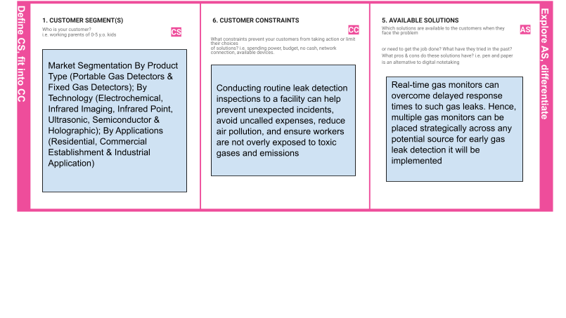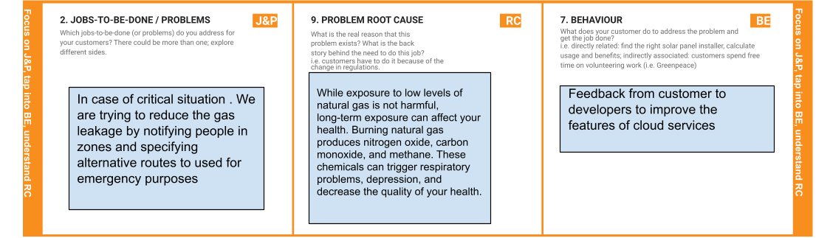

**Project Title:** Gas Leakage Monitoring and Alerting System **Team ID:** PNT2022TMID34760

# 3. TRIGGERS TR

What triggers customers to act? i.e., seeing their neighbor installing solar panels, reading about a more efﬁcient solution in the news.

# 10. YOUR SOLUTION SL

If you are working on an existing business, write down your current solution ﬁrst, ﬁll in the canvas, and check how much it ﬁts reality.

If you are working on a new business proposition, then keep it blank until you ﬁll in the canvas and come up with a solution that ﬁts within customer limitations, solves a problem and matches customer behavior.

# CHANNELS of Behavior CH

## ONLINE

What kind of actions do customers take online? Extract online channels from #7

## OFFLINE

What kind of actions do customers take ofﬂine? Extract ofﬂine channels from #7 and use them for customer development.

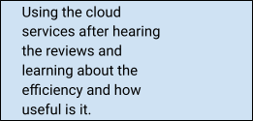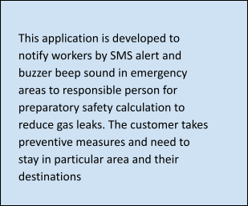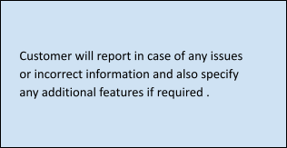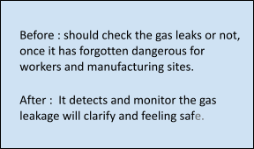

# 4. EMOTIONS: BEFORE / AFTER EM

How do customers feel when they face a problem or a job and afterwards?

i.e., lost, insecure > conﬁdent, in control—use it in your communication strategy & design.